

**University Institute of Information Technology,**

**PMAS-Arid Agriculture University,**

**Rawalpindi Pakistan**

**Video Classification And Indexing**

***By***

**Ahsan Yousaf 17-ARID-1284**

**Hina Shabbir 17-ARID-1324**

**Anum Bibi 17-ARID-1292**

***Supervisor***

**Mr. Zeeshan Javed**

***Bachelor of Science in Computer Science (2017-2021)***

**The candidate confirms that the work submitted is their own and appropriate  
 credit has been given where reference has been made to the work of others**.

**DECLARATION**

We hereby declare that this software, neither whole nor as a part has been copied out from any source. It is further declared that we have developed this software documentation and accompanied report entirely on the basis of our personal efforts. If any part of this project is proved to be copied out from any source or found to be reproduction of some other. We will stand by the consequences. No Portion of the work presented has been submitted of any application for any other degree or qualification of this or any other university or institute of learning.

Ahsan Yousaf Hina Shabbir Anum Bibi

--------------------------- --------------------------- ---------------------------

**CERTIFICATE OF APPROVAL**

It is to certify that the final year project of BS (CS)“**video classification and indexing** ” was developed by“ **Ahsan Yousaf, Registration 17-ARID-1284”**, “**Hina Shabbir, Registration 17-ARID-1324”**and “**Anum Bibi, Registration 17-ARID-1292”**under the supervision of“ **Mr. Zeeshan Javed** ” and that in their opinion; it is fully adequate, in scope and quality for the degree of Bachelors of Science in Computer Science.

---------------------------------------

**Supervisor**

---------------------------------------

**External Examiner (If any)**

---------------------------------------

**Administrator UIIT**

**Executive Summary**

In public places, there is often a need for monitoring people and different activities going on, which can be referred later for many reasons including security. Appointing humans for this task involves many problems such as increased employee hiring, accuracy problem, trust, no proof for later use, and also the fact that a human can remember things till a certain time limit. Talking about the current security system, they use dumb still cameras with a continuous recording facility ir-respective of the fact that any event may happen or not. Moreover they are usually pointing at a specific user defined locations so more than one cameras are required to cover the entire region.

To prevent all these problems from prevailing, the CSCS is developed. It is a surveillance system, which provides solution to many of these problems. It is a stand-alone application which doesn’t require any computer to operate. It monitors different situations using a camera which is able to rotate intelligently based on sensor messages and captures the scene in the form of video or photos later reference as well.

**C**ustomizable **S**urveillance **C**ontrol **S**ystem**(CSCS)** is a surveillance system that can be assigned a sensor type as in our case a heat sensor is used, it works accordingly, rotates the camera upon event detection and perform user defined actions like capturing video and stores them, for the future use.

It is an embedded system consisting of Linux fox kit with embedded a running server application also a camera, USB storage device and a sensor node base station is attached with fox kit. LAN communication is used by user to download the videos and to operate the system manually.

**Acknowledgement**

All praise is to Almighty Allah who bestowed upon us a minute portion of His boundless knowledge by virtue of which we were able to accomplish this challenging task.

We are greatly indebted to our project supervisor “Mr. Zeeshan Javed” for personal supervision, advice, valuable guidance and completion of this project. We are deeply indebted to him for encouragement and continual help during this work.

And we are also thankful to our parents and family who have been a constant source of encouragement for us and brought us the values of honesty & hard work.

Ahsan Yousaf Hina Shabbir Anum Bibi

--------------------------- --------------------------- ---------------------------

**Abbreviations**

|  |  |
| --- | --- |
| **SRS** | Software Requirement Specification |
| **PC** | Personal Computer |
|  |  |
|  |  |
|  |  |

**Table of Contents**

**Introduction 1**

1.1 Brief 2

1.2 Relevance to Course Modules 2

1.3 Project Background 3

1.4 Literature Review 3

1.5 Methodology and Software Life Cycle 5

**Problem Definition** 6

2.1 Purpose 7

2.2 Product Functions 7

2.3 Proposed Architecture 7

2.4 Project Deliverables 8

2.5 Operating Environment 8

2.6 Assumptions and Dependencies 8

**Requirement Analysis** 9

3.1 Functional Requirments 10

3.2 Non – Functional Requirments 11

3.2.1 Usability 11

3.2.2 Reliability 11

3.2.3 Performance 11

3.2.4 Supportability 11

3.2.5 Design Constraints 11

3.2.6 Licensing Requirements 11

3.3 Use case Model 12

3.3.1 Use Case Diagarm 12

3.3.2 Actors Discription 16

3.3.3 Use Case Discription 17

**The Design** 21

4.1 UML Structural Diagrams 22

4.1.1 Component Diagram 22

4.1.2 Deployment Diagram 26

4.2 UML Behavioral Diagrams 27

4.2.1 Activity Diagrams 27

4.2.2 State Machine Diagrams 29

4.3 UML Interaction Diagrams 30

4.3.1 Sequence Diagrams 30

**Implementation** 33

5.1 Communication Protocol Implementation 34

5.2 PC Application Implementation 36

5.3 Embedded Application Implementation 38

5.4 Wireless Sensor Application Implementation 51

**Testing and Evaluation** 52

6.1 Verification 53

6.1.1 Functional Testing 53

6.1.2 Static Testing 57

6.2 Validation 57

6.3 Usability Testing 57

6.4 Unit Testing 57

* 1. Integration Testing 57

6.6 System Testing 57

**GUI** 58

**Future Work** 70

**References** 72

**List of Figures**

Fig 1.1 Block Diagram 8

Fig 2.1 Use Case Diagram 9

# Chapter 1: Introduction

This chapter is all about introduction of our project which include a brief introduction of project, literature background of our project and methodology we will use in our system.

# Brief

We are creating a platform that will implement video classification and video indexing system. User would be able to upload a video of maximum 5 minutes duration. System allows user to upload and search a video. Proposed system will provide more accurate result by implementing new technologies and algorithms of image processing to perform video classification. Outcomes of the system are video classification and indexing. OpenCV, TensorFlow, PyCharm, Python, Anaconda 3.7 are the tools, and agile methodology we will use in the development of our system.

# Relevance to Course Modules

Following Courses are related to our project that we learnt in our degree.

* Software Engineering-I and Software Engineering-II help us to design UML diagrams and Use case model for our system.
* Database systems and Distributed Database system help us in designing and maintaining database for our system.

# Project Background

Approaches to classify video are: using text modality, using audio, video and combination of these. The majority of the literature describes approaches that utilize features from a single modality. [1]

Our main idea is to develop a desktop application with the implementation of video classification and indexing. We will classify videos using two modality of the video one is audio and second is visual. Video Classification using two modality will give us better result rather than single modality.

# Literature Review

**video classification**

According to a review paper of video classification, to classify a video, feature are drawn from three modalities: text, audio and visual. Approaches to classify video are: using text modality, using audio, video and combination of these. The majority of the literature describes approaches that utilize features from a single modality. [1]

**Machine learning techniques used for video classification**

Proposed work for video classification of a review paper is “The methods reviewed so far in this paper uses unsupervised learning to develop video classification methods. This work uses the strength of unsupervised learning method and fuzziness to attain better classifications. In this proposed work the video data is first divided into key clips and then we extract the visual features like color, texture and motion vectors. These features are then subjected to supervised deep learning models and the then results then undergo Fuzzy C means clustering. With the objective of further improving the results we apply an optimization algorithm which then categorizes the video under a label. The proposed system is shown in figure.” [2]

Video Data

Key Clips

Visual Features

(Color, texture,

Motion vectors)

Categories

Supervised deep learning model

Optimizing algorithm

Fuzzy C-means Clustering

**Video indexing technology**

**“**To make searching video easier, FX Palo Alto Laboratory, Inc., located in Silicon Valley, has developed a video indexing technology that is able to find specific scenes in videos by the text (character strings) appearing in them. With this technology, by simply entering a search term, users can search for lecture videos and scenes in which that term appears.”[3]

# Analysis from Literature Review

“Approaches to classify video are: using text modality, using audio, video and combination of these. The majority of the literature describes approaches that utilize features from a single modality. [1]”

Our proposed system will work with combination of two modularity audio and visuals, to classify a video. And to achieve indexing of the data, audio and visual indexing would be perform and by combining result of both, final indexing result would be produced.

# Methodology and Software Lifecycle for This Project

Video Classification and indexing system will provide more accurate result by implementing new technologies and algorithms of image processing to perform video classification. For implementation of this system we will use agile methodology. The agile approach is focused on giving high priority from the very beginning of the development cycle to customer involvement. The aim to keep the customer engaged at very stage so that at the end they have a product for which they are satisfied.

* + 1. Rationale behind Selected Methodology

We use Agile methodology because Agile helps teams to deliver a prototype and improve it in each cycle and this strategy saves the customer money and time because at each point of production the customer checks and approves the product. If there are problems then modification can be made during production cycles to fix the issue.

**Chapter 2: Problem Definition**

Problem statement of our project and the solution to that problem is discuss in this chapter.

Our project deliverables, project environment and assumption and dependencies of our project is also part of this chapter.

# Problem Statement

Number of platform are there in the market having video content but they are lacking of video classification and indexing process which leads towards massive amount of content on the platform without any classification which cause irrelevant suggestions to users.

# Purpose

Purpose of our system is to classify videos into various categories and perform indexing on the videos so that it is easier and faster to search the videos category wise due to classification and indexing performed on the videos.

# Product Function

Our product function will be to perform video classification on the uploaded video and it will place it in a specific category to which it belongs and it will further perform indexing on the videos so they are easy and quick to search.

# Purposed Architecture

Our proposed system will work with video classification and indexing. Video classification and indexing process would be done, when a user tried to upload any video.

Video classification help system to detect the type of video content and make decision, what type of content is in the video. And indexing would help to organize all data so that when user try to find any type of video, system will just fetch video that fall into that search tag.

The diagram 2.1 shows flow of control in the system

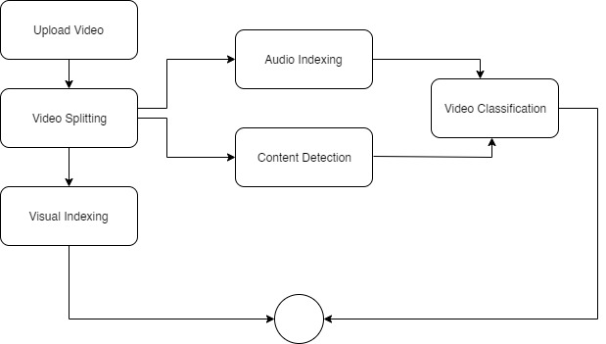

*Figure 2.4*

# Project Deliverables

First deliverable of the project will be a brief proposal of the project which will highlight all the major requirements and all the important information about the system. A system with the implementation of video classification and indexing is final deliverable of our project. Complete system development report or documentation will also be our deliverable.

# Operating Environment

We are building our system in python so it will be cross platform and will run on the latest versions of Operating Systems and machines.

But as we are developing it on window 10 so our system will work on windows with python 3.9 installed on it having at least 4GRAM and I5 processor

# Assumptions And Dependencies

Our assumption is that our system should be cross platform and there should be no dependency of the machine that it will run on so we are making our system in python so it can work on all type of operating systems and machines with suitable hardware and software.

# Chapter 3: Requirement Analysis

Software Requirements Specification (SRS) report should be included in this chapter.

# Use Cases

Use cases are a widely used and highly regarded format for capturing requirements. Before writing functional requirement use cases can help you to understand the requirements in the way user expect. Following table presents you not only the template to write use case(s) as well as guides you to write each section with example.

|  |  |
| --- | --- |
| **Use Case ID:** | UC-1 |
| **Use Case Name:** | User Signup |
| **Actors:** | User |
| **Description:** | User create an account and become a registered user. User enter their personal details. |
| **Trigger:** | New user want to create an account. |
| **Preconditions:** | Email should be unique. |
| **Postconditions:** | User entered data is stored in user account and user get id and password to login to the system. |
| **Normal Flow:** | When the user accesses the system feature to create an account, this use case starts   1. The user enters the required values for the User Account  * Name * Gender * User Name * Password * Confirm Password   And then will press the Submit button.   1. The system validates the entered User Account information. 2. The User Account information values are stored in the User Account. The system notifies the user that the account has been created. |
| **Alternative Flows:** | 1a: User entered invalid user account information, the following occurs:   1. The system warn the user name is already exist in the system. 2. The system warn the user password and confirm password should be same. 3. The user reenters the data and it is re-validated by the system. 4. The User Account Information is processed if valid information is entered. |
| **Exceptions:** |  |
| **Includes:** |  |
| **Special Requirements:** |  |
| **Assumptions:** |  |
| **Notes and Issues:** |  |

|  |  |
| --- | --- |
| **Use Case ID:** | UC-2 |
| **Use Case Name:** | User Login |
| **Actors:** | User |
| **Description:** | User enter their user name and password for login. |
| **Trigger:** | User want to login the system. |
| **Preconditions:** | Should have an account and user name and password should correct. |
| **Postconditions:** | The User is authenticated and user get complete access of the System. |
| **Normal Flow:** | The use case starts when the user accesses the system's Log in feature.   1. User enter user username and password. 2. The system validates the entered information, after pressing login button, making sure that the entered email and password are valid. 3. The User is login to the system. |
| **Alternative Flows:** | 1: If User entered invalid user name and password system display the alert when user press login button. |
| **Exceptions:** |  |
| **Includes:** | User have an account. |
| **Special Requirements:** |  |
| **Assumptions:** |  |
| **Notes and Issues:** |  |

|  |  |
| --- | --- |
| **Use Case ID:** | UC-3 |
| **Use Case Name:** | User Logout |
| **Actors:** | User |
| **Description:** | This use case allow the user to logout the system. |
| **Trigger:** | User want to logout from the system. |
| **Preconditions:** | Login to the system. |
| **Postconditions:** | Exit to the system. |
| **Normal Flow:** | 1: Press logout button.  2: System returns the user to the login screen. |
| **Alternative Flows:** |  |
| **Exceptions:** | The user is not Login. |
| **Includes:** | User must be login. |
| **Special Requirements:** |  |
| **Assumptions:** |  |
| **Notes and Issues:** |  |

|  |  |
| --- | --- |
| **Use Case ID:** | UC-4 |
| **Use Case Name:** | Upload video |
| **Actors:** | User |
| **Description:** | User upload the video using upload video Button. |
| **Trigger:** | User want to upload the video. |
| **Preconditions:** | User should be login and have video. |
| **Postconditions:** | Video should be uploaded and displayed in the system. |
| **Normal Flow:** | 1: Choose video from computer to upload to the system.  2: Enter title of the video and other required details.  3: Press “Upload” button  4: System will upload the video. |
| **Alternative Flows:** |  |
| **Exceptions:** | 1: Video file format is miss match.  2: Video size is too large to upload. |
| **Includes:** |  |
| **Special Requirements:** |  |
| **Assumptions:** |  |
| **Notes and Issues:** |  |

|  |  |
| --- | --- |
| **Use Case ID:** | UC-5 |
| **Use Case Name:** | Search Video |
| **Actors:** | User |
| **Description:** | User can search any type of video using search bar. |
| **Trigger:** | User wants to search video. |
| **Preconditions:** | User must be Login and must have title or keywords that relate to the video. |
| **Postconditions:** | List of video should be displayed. |
| **Normal Flow:** | 1: Go to search bar.  2: Type title of the video or keyword related to the video.  3: Press Enter button or search icon next to search bar.  4: The system will display the related results of video. |
| **Alternative Flows:** | 2a: If Title of the video or keyword not match then system give a message, video not found. |
| **Exceptions:** |  |
| **Includes:** |  |
| **Special Requirements:** |  |
| **Assumptions:** |  |
| **Notes and Issues:** |  |

|  |  |
| --- | --- |
| **Use Case ID:** | UC-6 |
| **Use Case Name:** | Video splitting |
| **Actors:** | User |
| **Description:** | Using an OpenCV library here user will perform video splitting video will split into text audio and visuals. |
| **Trigger:** |  |
| **Preconditions:** | Video should be type of MP4. |
| **Postconditions:** | Video will split into audio, text and visual and save in different folders. |
| **Normal Flow:** | 1: Take the video that user upload to the system.  2: Perform splitting using OpenCV library of python. |
| **Alternative Flows:** |  |
| **Exceptions:** | 1: Video file format is miss match. |
| **Includes:** | User have to upload a video. |
| **Special Requirements:** |  |
| **Assumptions:** |  |
| **Notes and Issues:** |  |

|  |  |
| --- | --- |
| **Use Case ID:** | UC-7 |
| **Use Case Name:** | Content detection |
| **Actors:** | User |
| **Description:** | This use case describes when user perform splitting, visual will be process and system will detect the type of content used in visual using OpenCV library. |
| **Trigger:** |  |
| **Preconditions:** | All visuals/frames should be of Jpeg type. |
| **Postconditions:** | Type of content should be detect from frame. |
| **Normal Flow:** | 1: Get the visual that has been separated while splitting.  2: Detect the type of content in the visual.  3: System Classify the visual. |
| **Alternative Flows:** |  |
| **Exceptions:** | If visual/frames will not in the format of Jpeg then system will not allow to content detection. |
| **Includes:** | User have to upload a video and video should be in the format of mp4. |
| **Special Requirements:** |  |
| **Assumptions:** |  |
| **Notes and Issues:** |  |

|  |  |
| --- | --- |
| **Use Case ID:** | UC-8 |
| **Use Case Name:** | Video Classification |
| **Actors:** | User |
| **Description:** | Type of content in the visual is already detected so here output of that process and audio of the video that split before will be input of this function and by combining both classification of video will be perform using OpenCV, Pandas, Keras and Deep learning algorithms. |
| **Trigger:** |  |
| **Preconditions:** | All visual should be preprocessed and audio should be of type mp3. |
| **Postconditions:** | Video will be classify and its type should be define in system. |
| **Normal Flow:** | 1: Get the processed visuals and audio.  2: Combine the result of both input and apply algorithms.  3: Classify the video. |
| **Alternative Flows:** |  |
| **Exceptions:** | If visual will be not preprocessed and audio will not be in the format of mp3 then system will not allow to classify the video. |
| **Includes:** | User have to upload a video and video should be in the format of mp4 then all visual should be preprocessed and audio should be of type mp3. |
| **Special Requirements:** |  |
| **Assumptions:** |  |
| **Notes and Issues:** |  |

|  |  |
| --- | --- |
| **Use Case ID:** | UC-9 |
| **Use Case Name:** | Visual indexing |
| **Actors:** | User |
| **Description:** | When system perform splitting, visuals will be process, text in the frame and frame itself will be separately save in the folder. To do all this we will use Apache solr. |
| **Trigger:** |  |
| **Preconditions:** | All visuals/frames should be of type Jpeg. |
| **Postconditions:** | Text in the visual should be detect and save separately. |
| **Normal Flow:** | 1: Get the visual  2: Process visual and separate text in the frames and frames itself.  3: Perform indexing on behalf of text generated from visuals. |
| **Alternative Flows:** |  |
| **Exceptions:** | If visual/frames will not in the format of Jpeg then system will not allow to content detection. |
| **Includes:** | User have to upload a video and video should be in the format of mp4. |
| **Special Requirements:** |  |
| **Assumptions:** |  |
| **Notes and Issues:** |  |

|  |  |
| --- | --- |
| **Use Case ID:** | UC-10 |
| **Use Case Name:** | Audio indexing |
| **Actors:** | User |
| **Description:** | When system perform splitting, later audio will be process, voice recognition would be perform and it will convert it into text. |
| **Trigger:** | User want to upload a video. |
| **Preconditions:** | Audio should be of type mp3. |
| **Postconditions:** | Indexing of audio, audio and text generated from audio would be save separately. |
| **Normal Flow:** | 1: Get audio that split from video before.  2: Using Speech recognition and librosa analysis the audio and convert it into text.  3: Perform indexing on behalf of text generated from audio. |
| **Alternative Flows:** |  |
| **Exceptions:** | If visual/frames will not in the format of Jpeg then system will not allow to content detection. |
| **Includes:** | User have to upload a video and video should be in the format of mp4. |
| **Special Requirements:** |  |
| **Assumptions:** |  |
| **Notes and Issues:** |  |

# Functional Requirements

**FOR USER MODULE:**

**1**

**NAME:** User Signup

**DESCRIPTION**: User enter their personal details.

**INPUT:** User enter Name, Gender , User Name, Password and Confirm password.

**OUTPUT:** Confirmation dialogue box to display message “account create successfully” or “Account creation failed”.

**SOURCE:** Mouse and Keyboard.

**DESTINATION:** on screen.

**PRECONDITION:** Username should be unique.

**POSTCONDITION:** User get username and password to login to the system.

**ACTION:**

Step 1: Enter all required details.

Step 2: press “sign up” button.

**2**

**NAME:**  User Login.

**DESCRIPTION**: User enter their username and password for login.

**INPUT:** User enter username and password.

**OUTPUT:** Show dashboard to the user.

**SOURCE:** Mouse and Keyboard.

**DESTINATION:** on screen.

**PRECONDITION:** Should have an account and username and password should correct.

**POSTCONDITION:** User get complete access of the System.

**ACTION:**

Step 1: Enter username and password.

Step 2: press “login” button

**3**

**NAME:**  User Log out

**DESCRIPTION**: user is login to the system and when it press logout button, system will terminate its access to the system.

**INPUT:** user click on logout button.

**OUTPUT:** Display the Login interface.

**SOURCE:** Mouse

**DESTINATION:** Computer screen

**PRECONDITION:** user must be login

**POSTCONDITION:** User must be logout.

**ACTION:**

Step 1: press “ logout ” button

**4**

**NAME:** Upload video

**DESCRIPTION**: User will upload the video using a button “upload video”.

**INPUT:** Video

**OUTPUT:** Video should be uploaded in the system.

**SOURCE:** Mouse

**DESTINATION:** Computer Screen

**PRECONDITION:**  User should be login and have video.

**POSTCONDITION:** Video must be loaded.

**ACTION:**

Step 1: Choose video from computer to upload to the system.

Step 2: Enter title of the video and other required details.

Step 2: Press “Upload” button

**5**

**NAME:** Search video

**DESCRIPTION**: User can search any type of video using search bar.

**INPUT:** title or keywords that relate to video

**OUTPUT:** view the list of video.

**SOURCE:** mouse and keyboard

**DESTINATION:** Computer Screen

**PRECONDITION:**  User must be Login and must have title or keywords that relate to the video

**POSTCONDITION:** List of video should be displayed

**ACTION:**

Step 1: Go to search bar.

Step 2: Type title of the video or keyword related to the video.

Step 2: Press Enter button or search icon next to search bar.

**FOR SYSTEM MODULE:**

**6**

**NAME:** Video splitting

**DESCRIPTION**: Using an OpenCV library here system will perform video splitting Video will split into text audio and visuals.

**INPUT:** Video

**OUTPUT:** Audio, text and visuals.

**SOURCE:** OpenCV and system

**DESTINATION:** System

**PRECONDITION:**  video should be type of MP4.

**POSTCONDITION:** Video will split into audio, text and visual and save in different folders.

**ACTION:**

Step 1: Take the video that user upload to the system.

Step 2: Perform splitting using OpenCV library of python.

**7**

**NAME:** Content detection

**DESCRIPTION**: When system perform splitting, visual will be process and system will detect the type of content used in visual using OpenCV library.

**INPUT:** Visuals/frames

**OUTPUT:** Classification of frames.

**SOURCE:** OpenCV and System

**DESTINATION:** System

**PRECONDITION:**  All visuals/frames should be of Jpeg type.

**POSTCONDITION:** Type of content should be detect from frame.

**ACTION:**

Step 1: Get the visual that has been separated while splitting.

Step 2: detect the type of content in the visual

Step 3: Classify the visual

**8**

**NAME:**  Video Classification

**DESCRIPTION**: Type of content in the visual is already detected so here output of that process and audio of the video that split before will be input of this function and by combining both classification of video will be perform using OpenCV, Pandas, Keras and Deep learning algorithms.

**INPUT:** Processed images and audio

**OUTPUT:** Classification would be done

**SOURCE:** OpenCV, Pandas, Keras and Deep learning algorithms and system.

**DESTINATION:** System

**PRECONDITION:**  All visual should be preprocessed and audio should be of type mp3.

**POSTCONDITION:** Video will be classify and its type should be define in system

**ACTION:**

Step 1: Get the processed visuals and audio.

Step 2: Combine the result of both input and apply algorithms.

Step 3: Classify the video

**9**

**NAME:** Visual indexing

**DESCRIPTION**: When system perform splitting, visuals will be process, text in the frame and frame itself will be separately save in the folder. To do all this we will use Apache solr.

**INPUT:** Visuals/frames

**OUTPUT:** Indexing of visuals and text.

**SOURCE:** Apache Solr and System

**DESTINATION:** System

**PRECONDITION:**  All visuals/frames should be of type Jpeg.

**POSTCONDITION:** Text in the visual should be detect and save separately.

**ACTION:**

Step 1: Get the visual

Step 2: Process visual and separate text in the frames and frames itself

Step 3: Perform indexing on behalf of text generated from visuals.

**10**

**NAME:** Audio indexing

**DESCRIPTION**: When system perform splitting, later audio will be process, voice recognition would be perform and it will convert it into text.

**INPUT:** Audio

**OUTPUT:** Indexing of audio.

**SOURCE:** Speech recognition, Librosa and System

**DESTINATION:** System

**PRECONDITION:**  Audio should be of type mp3.

**POSTCONDITION:** Indexing of audio, audio and text generated from audio would be save separately.

**ACTION:**

Step 1: Get audio that split from video before.

Step 2: Using Speech recognition and librosa analysis the audio and convert it into text.

Step 3: Perform indexing on behalf of text generated from audio.

# Non-Functional Requirements

* + 1. **Usability**

1. The interface of our system is user friendly and easy to get familiar with
2. There is no need to learn anything new to use this system.
3. There is no hard and fast rule or regulation that need to memorize to use the system.
   * 1. **Reliability**
4. The system is available 24/7.
5. The system never crash are hanged. Other than as a result of an operating error.
6. The system is able to recover from hardware and power failure and other natural disaster.
   * 1. **Performance**
7. The overall system should be fast and active responsive.
8. The system should be able to handle large amount of data comfortably.
9. Searching result would be more accurate due to indexing.
10. Response time of the system is between 100ms-200ms.
11. A one minute video may take 2-3 minute for uploading and classification.
12. Over project is specifically designed to classify video and indexing and it will provide more accurate result.

**Use Case Diagram:**

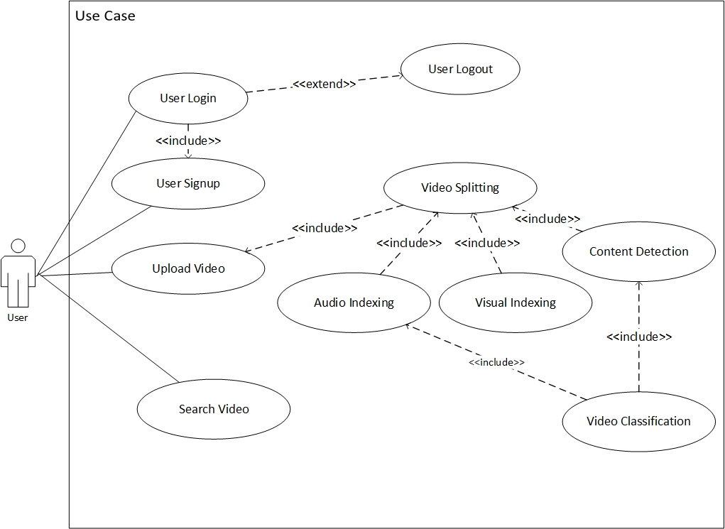

*Figure 3.1*

# Chapter 4: Design and Architecture

This chapter will discuss the design and architecture of our system.

**4.1 UML Structural Diagrams**

**4.1.1 Component Diagram**

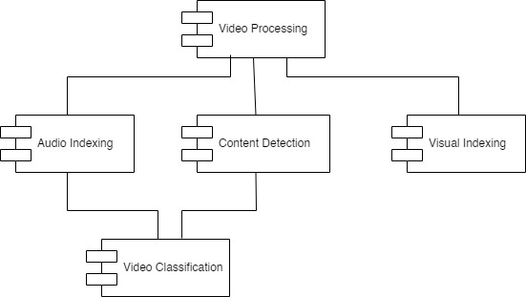

*Figure 4.1.1*

**4.1.2 Deployment Diagram**

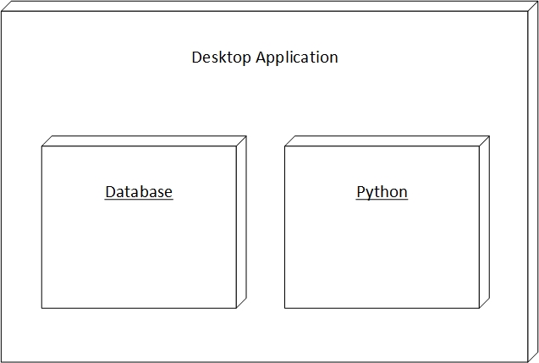

*Figure 4.1.2*

**4.2 UML Behavioral Diagrams**

**4.2.1. Class Diagram:**

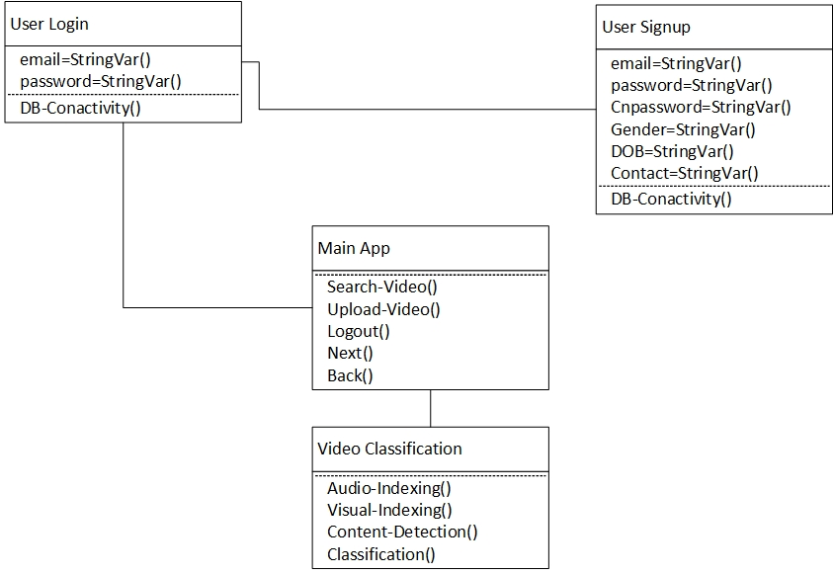

*Figure 4.2.1*

**4.2.1 Activity Diagram****s**

**4.2.1.1. Signup**

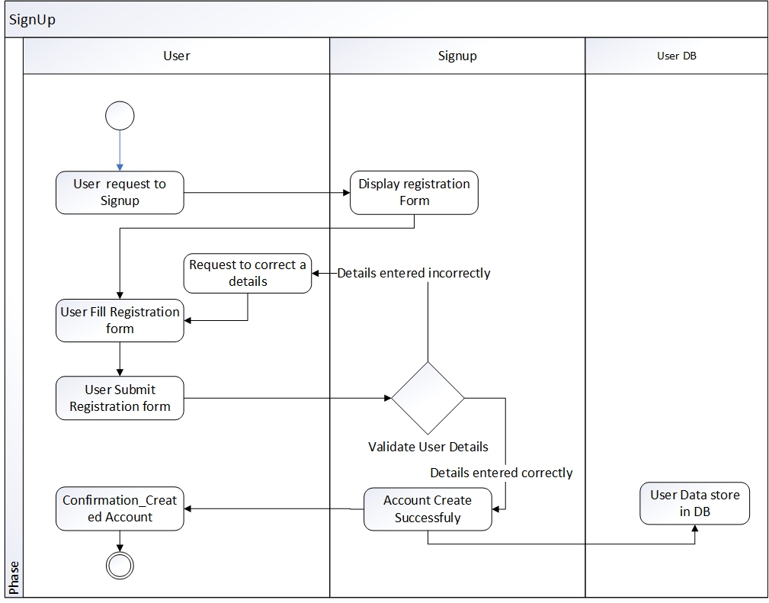

*Figure 4.2.1.1*

**4.2.1.2.** **Login**

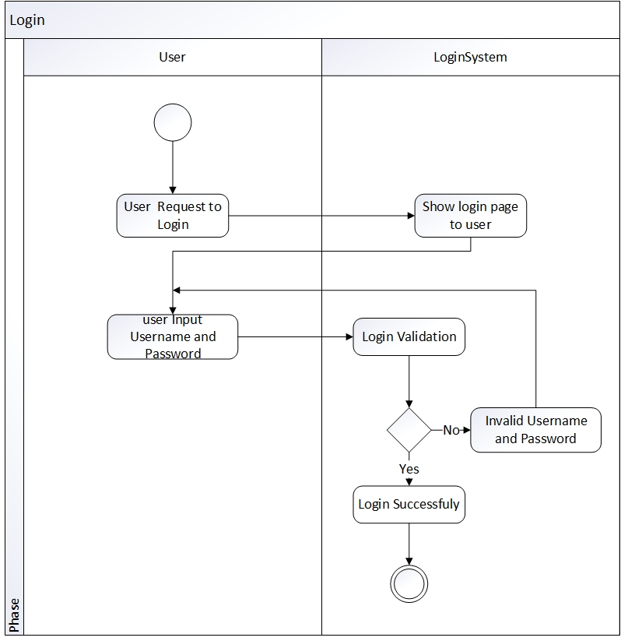

*Figure 4.2.1.2*

**4.2.1.3. Logout**

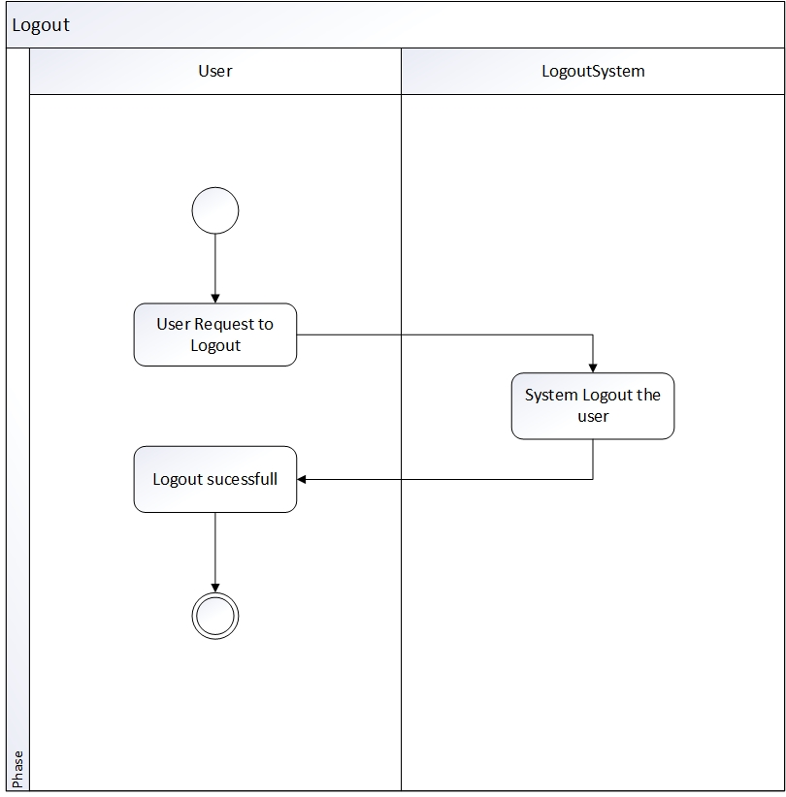

*Figure 4.2.1.3*

**4.2.1.4.** **Search Video**

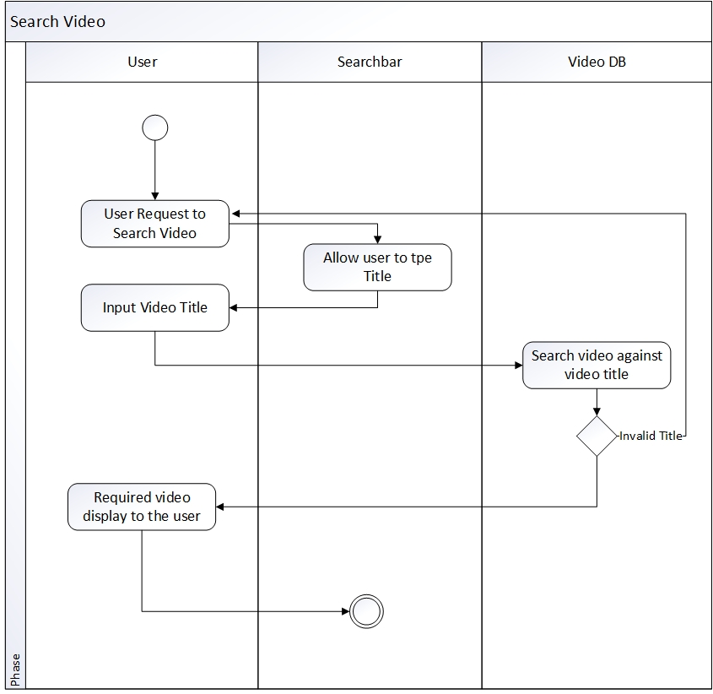

*Figure 4.2.1.4*

**4.2.1.5.** **Upload Video**

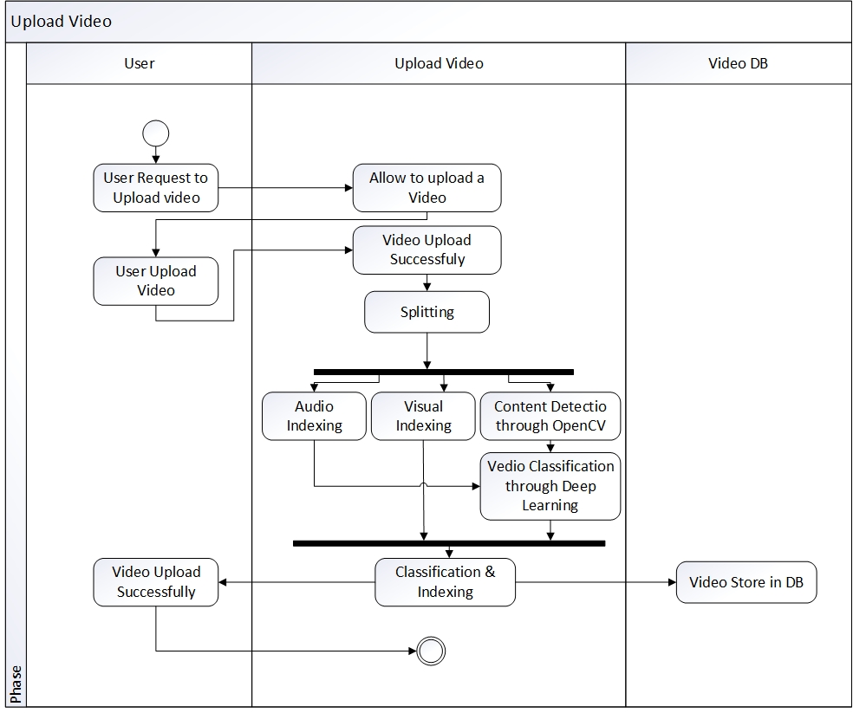

*Figure 4.2.1.5*

**4.2.2 State Machine Diagrams**

**4.2.2.1.** **Account**

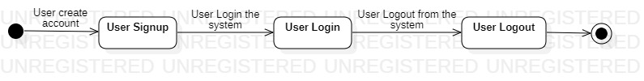

*Figure 4.2.2.1*

**4.2.2.2.** **Video**

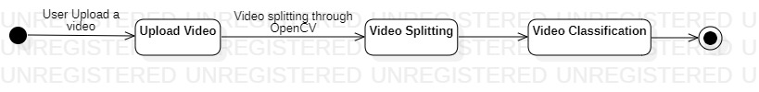

*Figure 4.2.2.2*

**4.2.2.3.** **Image**



*Figure 4.2.2.3*

**4.2.2.4.** **Audio**



*Figure 4.2.2.4*

**4.3 UML Interaction Diagrams**

**4.3.1 Sequence Diagrams**

**4.3.1.1. Signup**

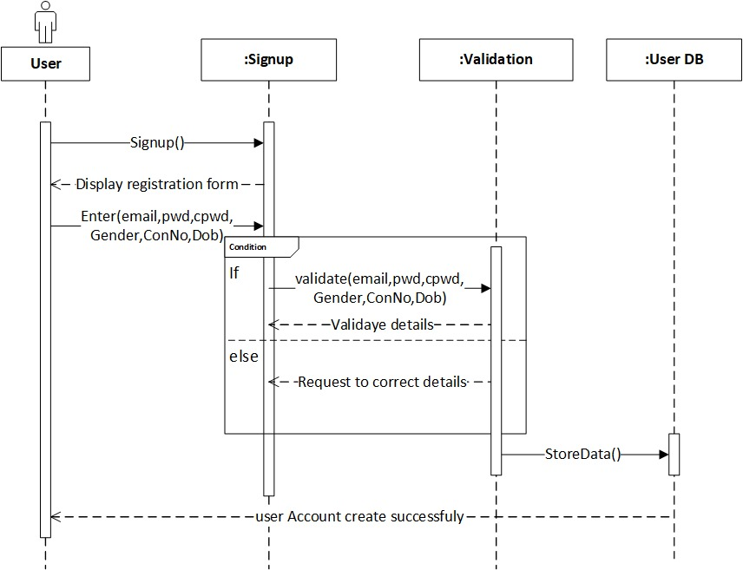

*Figure 4.3.1.1*

**4.3.1.2. Login**

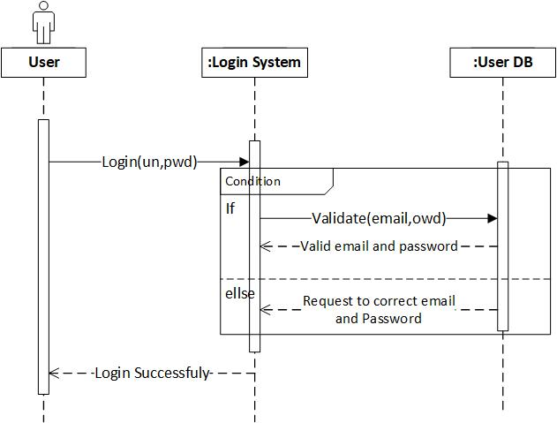

*Figure 4.3.1.2*

**4.3.1.3. Logout**

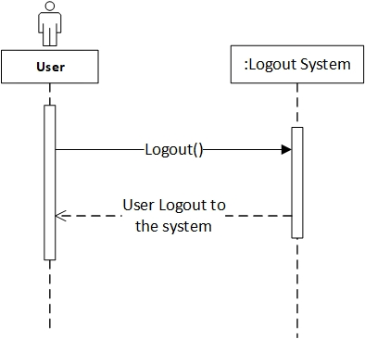

*Figure 4.3.1.3*

**4.3.1.4.Search Video**

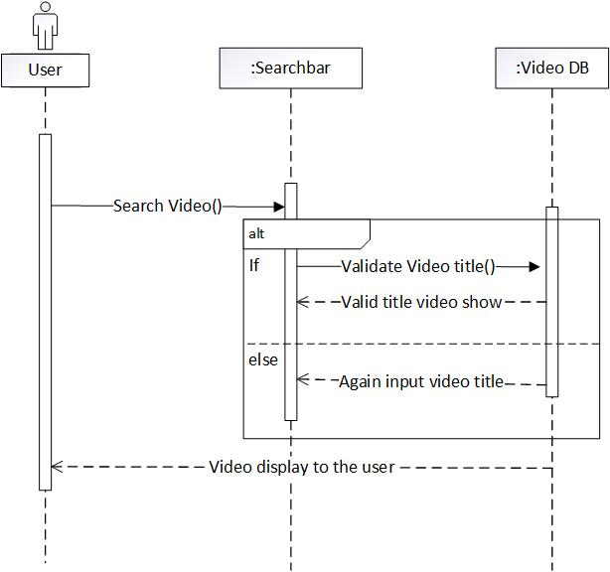

*Figure 4.3.1.4*

**Upload video:**

**4.3.1.5. Upload Video**

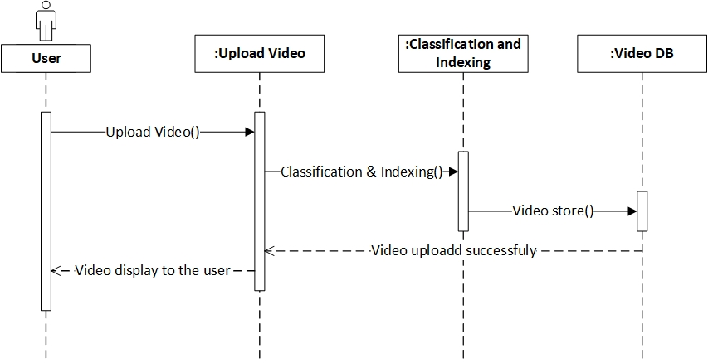

*Figure 4.3.1.5*

# Chapter 5: Implementation

In this chapter , we explain all the implementation of our project. Why we are using the IDE PyCharm, the libraries and the language Python.

# Language Python 3.7

* Python language is in the high demand in the market
* Python language is best choice for machine learning project because of its own libraries that make development very easy
* Helping material of python in form of documentation and video tutorial is widely available over internet.
* Python 3.7 support more libraries than latest version of python

# Libraries

* Tkinter
  + Version 2.3.2
  + Easy to configure with database
  + It is best for design simple and user friendly interface
  + Provide 15 types of widgets that help in designing GUI

* Pymysql
* Version 1.0.2
* For database connection
* Pymysql is best suitable with python
* OpenCV
* Version 4.5.1.48
* For video classification we need to analyze and classify the image and video, for that we need opencv

# Tool

# IDE (PyCharm 2020.2.3)

* PyCharm is smart code editor for python
* Readability of the code is good due to the different color of the keyword, classes and function etc.
* Free available on internet
* Compatible with all operating system
* Helps to write code in python quickly and efficiently

**WAMP**

* WAMP server version 3.2.3
* For database implementation
* WAMP provide support for MySQL
* We are developing a desktop app that will run without using any external resources, for that, WAMP is best choice

# User Interface



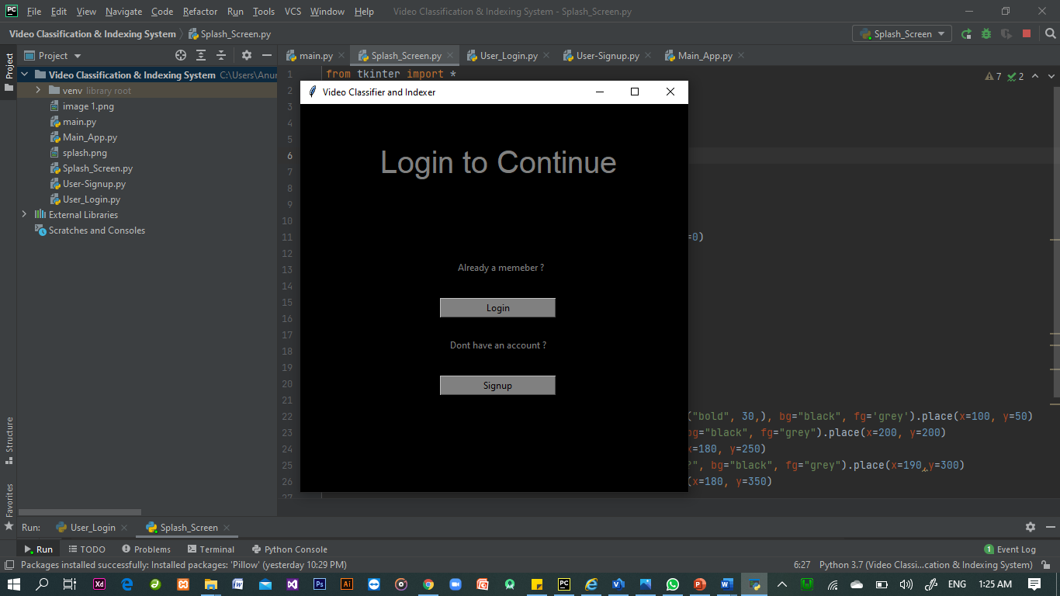

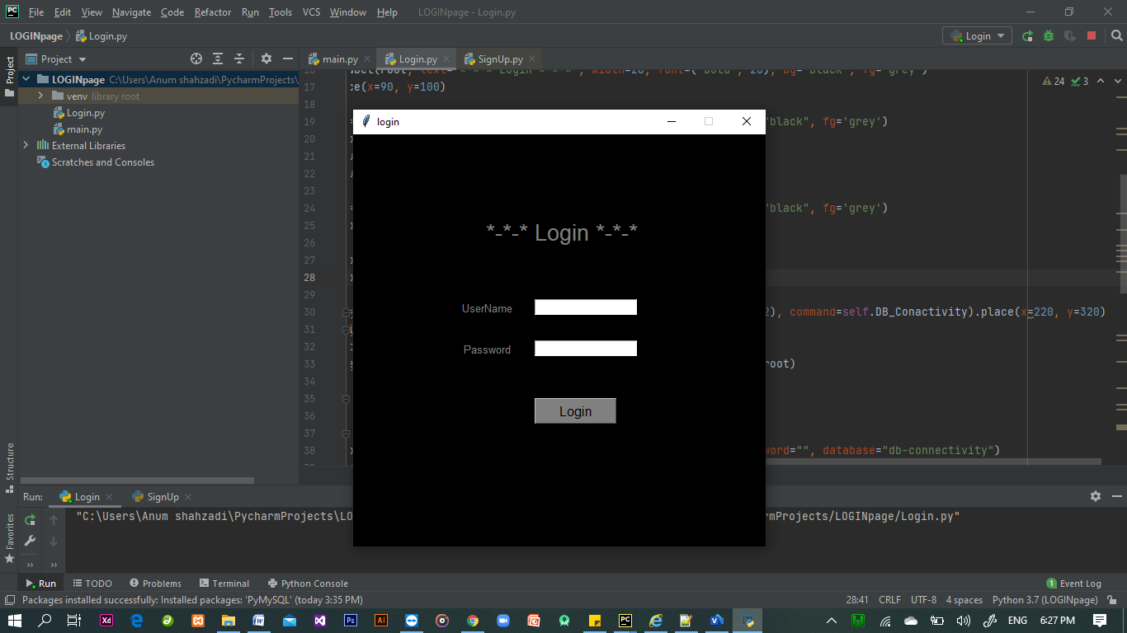

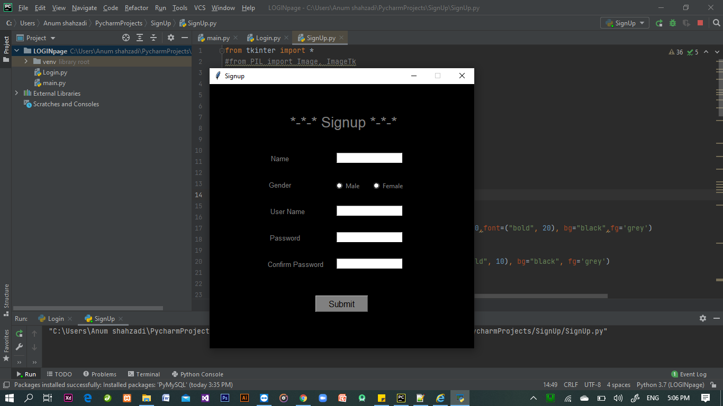

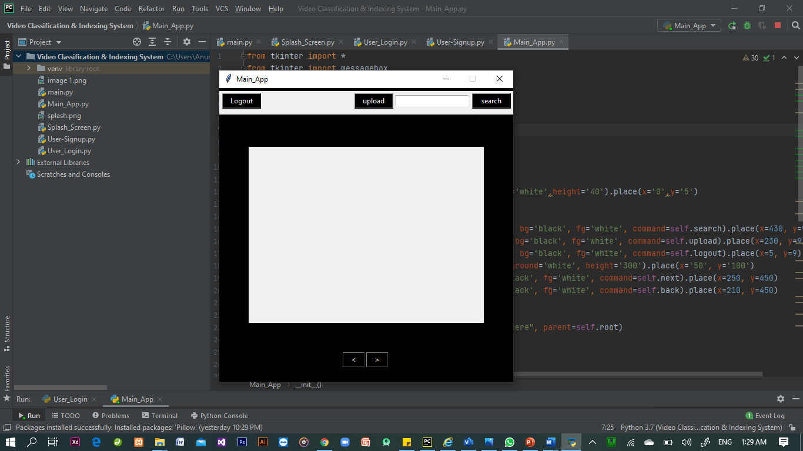

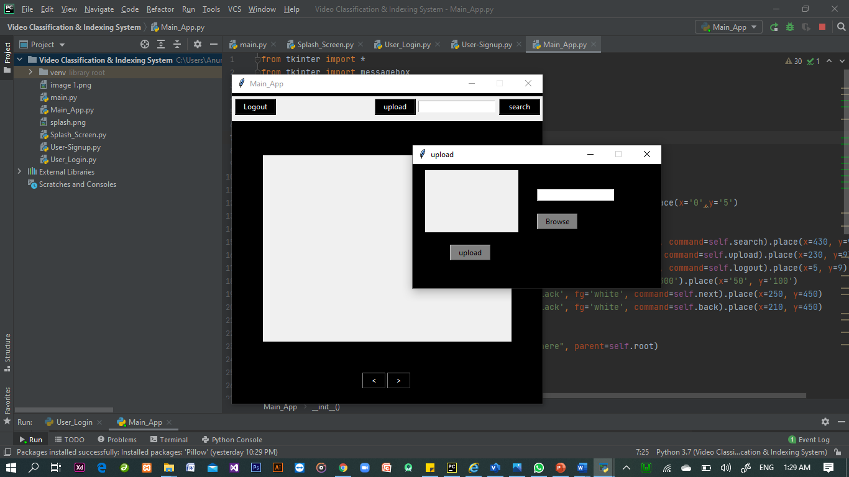

# Chapter 6: Testing and Evaluation

This chapter may include the following sections.

# Verification

Verification section.

# Validation

Validation section.

# Usability Testing

Usability testing section.

# Module / Unit Testing

Unit testing.

# Integration Testing

Integration testing.

# System Testing

System testing.

# Acceptance Testing

Acceptance testing.

# Stress Testing

Stress testing.

# Hardware Configuration for Testing

Hardware configuration.

# Evaluation

Evaluation section.

# Deployment

Evaluation section.

# Maintenance

Evaluation section.

# Chapter 7: Conclusion and Future Work

This chapter concludes the project and highlights future work.

# Conclusion

Conclusion section.

# Future Work

Future work section.

# References

[1]

“ ResearchGate ” research.net [online]. Available:

<https://www.researchgate.net/publication/3421929> [ Accessed : 22-oct-2020]

[2]

“ TRO India ” troindia.in [online]. Available:

<http://troindia.in/journal/ijcesr/vol4iss12/64-69.pdf> . [Accessed : 22-oct-2020]

[3]

“ fuji xerox” fujixerox.com [online]. Available:

[https://www.fujixerox.com/eng/company/technology/production/multimedia/talkminer.html/](https://www.w3schools.com/). [Accessed : 22-oct-2020]